|  |  |  |  |  |  |  |
| --- | --- | --- | --- | --- | --- | --- |
| Description: Vertical full colour positive | Safety Bay Senior High School | | | | | |
| **CHEMISTRY UNIT 3 & 4** | | | | | | |
| **Test #3:** | | | | | | |
| **Oxidation and Reduction** | | | | | | |
|  | | | | | | |
| **NAME:** | | |  | | | |
|  | | |  | | | |
| **Time allowed for this paper** | | | | | | |
| Reading time: | | 5 minutes | | | | |
| Working time: | | 50 minutes | | | | |
|  | | | | | | |
| **Structure of this paper:** | | | | | | |
| Section | | | Number of questions | Marks available | | Marks achieved |
| Section One: Multiple Choice | | | 8 | 8 | |  |
| Section Two: Short Answer | | | 7 | 42 | |  |
|  | | |  | | **Total** | ______ / 50 |

**Section One: Multiple Choice**

Answer all questions by circling the correct option. Only circle one option for each question.

1. Which one of the following is NOT an oxidation–reduction reaction?
2. 2Mg(s) + O2(g) → 2MgO(s)
3. Zn(s) + 2H+(aq) → Zn2+(aq) + H2(g)
4. 2H2O2(aq) → 2H2O(l) + O2(g)
5. Pb2+(aq) + 2Cl–(aq) → PbCl2(s)
6. In which of the following compounds is the oxidation number of manganese the **lowest**?
7. Mn2O3
8. K2MnO4
9. NaMnO4
10. MnO2

**Questions 3-4 refer to the following reaction:**

2 NaOH + Cℓ2 → NaCℓ + NaCℓO + H2O

1. Which option on the table below correctly identifies the oxidant and reductant in the above reaction?

**Oxidant Reductant**

* 1. NaOH Cℓ2
  2. Cℓ2 NaOH
  3. NaOH NaOH
  4. Cℓ2 Cℓ2

1. What term is used to describe this reaction?
   1. Displacement reaction
   2. Acid-base reaction
   3. Disproportionation reaction
   4. Electrolytic reaction
2. Which of the following chemical species is capable of converting Cu2+ into Cu(s)?
   1. Pt
   2. HCℓ
   3. Au
   4. Zn
3. Corrosion is a redox process. Which one of the following explains why coating iron with nickel protects the iron from corrosion?
   1. Nickel accepts electrons from iron
   2. Iron and nickel form an alloy that is particularly resistant to redox processes
   3. Nickel is a stronger oxidising agent than iron
   4. The thin coating of nickel prevents iron from reacting

**Question 7 refers to the following electrochemical cell:**

KNO3 salt bridge

platinum electrode

copper electrode

Fe3+

V

Fe2+

SO42-

Cu2+

SO42-

Reduction half-equations:

Fe3+ + e⁻ → Fe2+ E° = 0.77 V

Cu2+ + 2 e⁻ → Cu E° = 0.34 V

1. Which of the following equations would be used to calculate the voltage of the cell under standard conditions?

|  |  |
| --- | --- |
| (a) |  |
| (b) |  |
| (c) |  |
| (d) |  |

1. If a substance is oxidised, it means that
2. electrons have been transferred to it
3. it has lost electrons
4. it has produced oxygen in a reaction
5. it can now donate oxygen to another substance

**Section Two: Short Answer**

Write your answers in the spaces provided.

1. **(7 marks)**

Lead-acid storage batteries use Pb and PbO2 electrodes. Pb is the reducing agent, while PbO2 is the oxidising agent. Sulfuric acid solution is used as the electrolyte.

* 1. The overall battery reaction during discharge is given below. Write and balance the anode and cathode reactions for the lead-acid storage battery. (2 marks)

|  |  |
| --- | --- |
| **Anode reaction** |  |
| **Cathode reaction** |  |
| **Overall reaction** | Pb(s) + PbO2(s) + 4 H+(aq) + 2 SO42-(aq) → 2 PbSO4(s) + 2 H2O(ℓ) |

* 1. Draw a schematic diagram of the lead-acid battery showing the two half-cells. Label the anode, cathode and salt bridge, and indicate the direction of electron flow with an arrow. (2 marks)

* 1. i. With reference to the ‘electrical potential’ of a galvanic cell, describe how the lead-acid storage battery produces current. (2 marks)

ii. What determines the magnitude of the electrical potential of a cell? (1 mark)

1. **(4 marks)**

The following reaction shows a process used in the extraction and purification of gold:

Au(s) + 3 HNO3(aq) + 4 HCℓ(aq) → HAuCℓ4(aq) + 3 NO2(g) + 3 H2O(ℓ)

Identify the oxidising agent and reducing agent in this reaction. Give evidence to support your answer.

1. **(7 marks)**

An electrochemical cell consists of a tin electrode in a solution of 1.0 mol L-1 tin(II) nitrate, to create a Sn/Sn2+ half-cell, and a similarly constructed half-cell composed of a chromium electrode in a solution of 1.0 mol L-1 chromium(III) nitrate. The two electrodes are joined by a piece of copper wire. A salt bridge, as shown in the diagram below, joins the two solutions.

NH4NO3 salt bridge

Sn

Cr

1.0 mol L-1 Sn(NO3)2

1.0 mol L-1 Cr(NO3)3

V

1. On the diagram, label: (3 marks)
2. the anode
3. the direction of electron flow
4. the direction of cation flow in the salt bridge

(b) Write balanced anode and cathode reactions.

(2 marks)

|  |  |
| --- | --- |
| **Anode reaction** |  |
| **Cathode reaction** |  |

(c) Would sodium carbonate be suitable as a salt for the salt bridge? Explain. (2 marks)

**Question 12** **(6 marks)**

The following diagram shows a form of electrolysis:

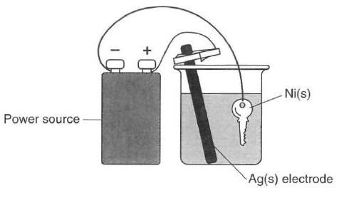

* 1. Give the name of this application of electrolysis, and describe its purpose in this particular scenario. (2 marks)

* 1. Write half-equations showing the process occurring at the: (2 marks)
     1. Anode:
     2. Cathode:
  2. Give the name or formula of a suitable electrolyte for this cell. (1 mark)

* 1. What is the purpose of the power source in this cell? (1 mark)

**Question 13** **(6 marks)**

‘Breathalysers’ are instruments used by police to measure the concentration of ethanol (C2H5OH) in a driver’s breath. One type of breathalyser used is a fuel cell. If the driver’s breath contains ethanol then a redox reaction will occur. The ethanol reacts to form ethanoic acid (CH3COOH) and oxygen from the air reacts to form water vapour. Both reactions occur in acidic conditions.

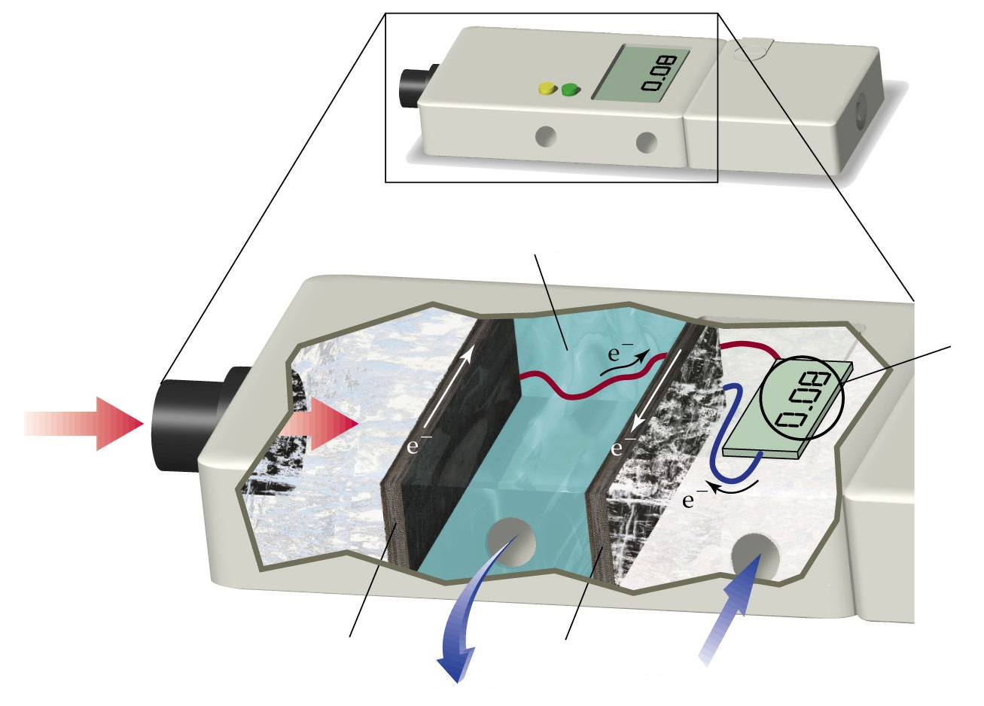

C2H5OH

acidic electrolyte

air   
intake

O2

waste   
products

Driver’s  
breath

Blood alcohol level

Electrode charge:

Electrode charge:

(a) Complete the half-equations below to show the reactions occurring in each section of the breathalyser. Both reactions occur in acidic conditions. (4 marks)

|  |
| --- |
| C2H5OH → CH3COOH |
| O2 → H2O |

(b) Label the diagram to show the charges of the two electrodes. (1 mark)

(c) What characteristic of this breathalyser allows it to be classified as a “fuel cell”? (1 mark)

**Question 14** **(4 marks)**

The lithium button cell, used to power watches and calculators, is a primary cell containing lithium metal. The lithium ion cell is a secondary cell that is used to power laptops.

|  |  |
| --- | --- |
| http://img.dxcdn.com/productimages/sku_34712_4.jpg | https://upload.wikimedia.org/wikipedia/commons/1/1a/Li_ion_laptop_battery.jpg |
| Lithium button cell | Lithium ion cell |

The half-equation for the reduction of lithium is:

Li+(aq) + e⁻ → Li(s) E° = -3.04 V

* 1. What is the difference between a primary and secondary cell? (1 mark)

* 1. Give one reason why lithium is used as a reactant in these galvanic cells. (1 mark)

Some early lithium metal batteries exploded when exposed to water.

* 1. Write a balanced equation for the reaction between lithium metal and water and explain why an explosion may occur. (2 marks)

**Question 15** **(8 marks)**

The bromate ion (BrO3⁻) is an ion formed by the ozonation of drinking water. Bromate ion is a powerful oxidising agent and can react in the presence of an acid to form bromine (Br2).

(a) Write a half-equation showing the reduction of the bromate ion to form bromine. (2 marks)

(b) Information about the oxidising power of the bromate ion can be gathered by observing what other species it is able to react with.

A student constructed the following two electrochemical cells and allowed each cell to operate for five minutes. In their notes they recorded the initial and final appearance of each half-cell. All cells were constructed under standard conditions.

**Electrochemical Cell #1 (EC1): Electrochemical Cell #2 (EC2):**

salt bridge

C(s)

BrO3⁻(aq)

Cr3+(aq)

C(s)

salt bridge

C(s)

BrO3⁻(aq)

Mn2+(aq)

C(s)

*Initial appearance:*

Pale pink solution

*Final appearance:*

Pale pink solution

*Initial appearance:*

Colourless solution

*Final appearance:*

Colourless solution

*Initial appearance:*

Green solution

*Final appearance:*

Orange solution

*Initial appearance:*

Colourless solution

*Final appearance:*

Brown solution

* + 1. Account for the colour changes in EC1 (Electrochemical Cell #1). (3 marks)

* + 1. Explain how the observations in EC1 and EC2 can be used to gain information about the standard reduction potential (E°) of bromate ions. (3 marks)